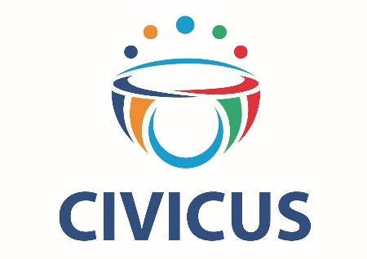

Oral statement
UN Human Rights Council – 46th Session
ID with the High Commissioner on Sri Lanka
24 February 2021
Delivered by Lisa Majumdar

Thank you, Madame President.
We welcome the report of the High Commissioner, which concludes that domestic initiatives for accountability have repeatedly failed to produce results.
Reneging on its international commitments has put any prospect of justice, truth and reparations in Sri Lanka at grave risk. This has been compounded by an escalation of attacks against civil society over the last months, particularly against groups and people working to further human rights.
As civic space has been squeezed tighter under the Rajapaksa administration, human rights lawyers, activists and academics have been targeted with arrests, intimidation or threats for speaking up. Independent NGOs are increasingly being silenced as the administration has sought to restrict them. With NGOs who document, monitor and report on past and current rights violations raided and attacked, it is abundantly clear that much-publicized national accountability processes are as such in name only.
The Human Rights Council once again has opportunity not only to secure justice and accountability for past crimes, but to protect those on the ground who are being subjected to human rights violations now, and those at risk – a risk increased by ongoing impunity – of further violations in the future. Warnings of a deteriorating human rights situation have been given by human rights defenders, by journalists, by Special Rapporteurs, by the High Commissioner. The Council must take action to ensure heightened scrutiny on Sri Lanka, including adopting a resolution mandating enhanced monitoring and other necessary steps towards furthering accountability.
We thank you.

