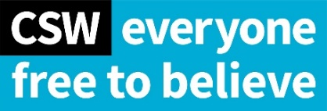
46th session of the Human Rights Council
Item 2: Interactive Dialogue on the High Commissioner’s report on Sri Lanka

Organisation: Christian Solidarity Worldwide (CSW)
Speaker: Claire Denman

Thank you, Madame President,

CSW thanks the High Commissioner for her report on Sri Lanka.

We regret the current government’s actions which undermine human rights through the militarisation of civilian government functions, the reversal of constitutional safeguards, the obstruction of accountability,
and the shrinking space for civil society.

We urge the international community to continue its scrutiny of Sri Lanka through the renewal of the resolution with regular reporting to the Human Rights Council and by enhancing investigative and monitoring mechanisms with a view to greater accountability.

As the High Commissioner’s report outlines, increasing ethno-nationalistic sentiments, have led to an increase in hate speech and discriminatory practices which threaten national security, peace-building efforts and respect among religion or belief groups. Social media in Sri Lanka continues to play a major role in the spread of stereotypes, misconceptions of religious minorities and hate speech with impunity, including throughout the COVID-19 pandemic.

We welcome the High Commissioner’s attention to the impact of the Covid-19 on the right to freedom of religion or belief. Forced cremations for Covid-19 victims have prevented Muslims from conducting their own practices in violation of burial rights, despite the World Health Organisation (WHO)’s guidelines stating that victims of COVID-19 can be buried or cremated.

CSW urges Sri Lanka to take concrete measures aimed at preventing hate speech online and offline, investigating and prosecuting those who incite violence against ethnic and religious minorities.

We further urge Sri Lanka to ensure that restrictions on the manifestation of freedom of religion or belief during COVID-19 are proportional and non-discriminatory.

Thank you.

