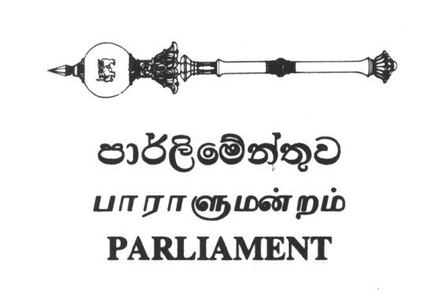

8th September, 2021
Heads of Missions in Geneva of the Core Group on Sri Lanka
Your Excellencies,
RESOLUTION 46/1 ON SRI LANKA PASSED AT THE 46TH SESSION OF THE UNHRC
We refer to the joint letter dated 15 January 2021 and our letter dated 24 February 2021, both of which are attached for your convenience.
Before the said resolution was passed and when its “zero” draft was released, we pointed out that we were disappointed with the resolution in that it does not even meet the basic expectations of the Tamil victims, especially in relation to international accountability for grave violations of international humanitarian law and human rights law. We further pointed out that the resolution's framing of issues was highly problematic and failed to locate them in the political context accurately and we went on to state the following: -
- We pointed out that Operative Paragraph 6 of the resolution stagnates accountability at the UNHRC in Geneva. It in effect it gives further time to Sri Lanka by calling for a) strengthen the Office of the High Commissioner on Human Rights work in relation to the consolidation, preservation and analysis of evidence in relation to the violations that took place and b) to explore strategies for accountability. The High Commissioner has been asked to report back to the Council on these measures at the 51st session, 18 months from the passage of the resolution - 18 months during which time the victims will be further alienated from any real prospects for justice and accountability.
- As we indicated in our letter dated 15 January 2021, as highlighted by the OHCHR in its January 2021 report and by the joint letter issued by former UN officials and independent experts including two former UN High Commissioners for Human Rights, we reiterate that the core group which includes two members of the UN Security Council must initiate steps to table a resolution in the UN Security Council to refer Sri Lanka to the International Criminal Court to inquire into all crimes committed, including the crime of genocide against the Tamil people. We pointed out that the matter being brought to the UNSC in itself would bring attention and urgency to Sri Lanka's chronic evasion of accountability and hence we urged that the core group signal their intention to bring forth a resolution to the UNSC for ICC referral without further delay.
- We also urged that consequent to efforts taken at the UNSC to refer Sri Lanka to the ICC that a resolution is presented to the UN General Assembly providing for an independent mechanism of evidence collection that would assist a future ICC referral.
- We asked that the resolution be amended to include the appointment of a Special Rapporteur to report on ongoing violations in Sri Lanka and the establishment of OHCHR field offices in the North and East.
- We pointed out that the resolution fails to recognise that the Government continues to use the military and government departments to expropriate the lands of Tamil people in the North-East under guise of security, development, archaeological research and conservation, and fails to recognise lack of progress over release of land held by the Sri Lankan Armed Forces in the last four years. It fails to take note of the fact that the occupational presence of the Sri Lankan Armed Forces in the Tamil speaking North-East particularly in the backdrop of no security sector reforms having been undertaken and where these very same armed forces are so pervasively accused of the gravest crimes known to international law.
- We also pointed out our concern that the resolution gives credence to the Office of Missing Persons and the Office of Reparations. Both these institutions are flawed in their original design and purpose but have been further undermined by the present Government which appointed individuals who have a history of blocking efforts at accountability.
- We also categorically stated that we refuse to accept the 13th amendment to Sri Lanka’s present constitution even as a starting point to the resolution of the Tamil National Question. Given the repeated failures of successive Governments both during the war and post-war to meet the political aspirations of the Tamil nation, namely, the enactment of a new constitution that recognises Sri Lanka as pluri-national federal state comprising of the Sinhala Nation and the Tamil Nation, both sovereign in their own right and exercising each of its right to self determination. We further called for Tamil People as a Nation be given an opportunity to exercise its right to self-determination and freely determine its political status.
Six moths have lapsed since the passing of resolution 46/1 on Sri Lanka. In these six months, every single warning that we alluded to have been proved to be true. In addition, innocent Tamil political prisoners continue to languish in jail without charge and without trial, even after key ministers including the minister of Justice proclaiming that the law under which these prisoners have been detained under, The Prevention of Terrorism Act (PTA), is unjust and needs to be at the very least amended.
It is the lived 74 years collective experience of the Tamil people that any further delay in not taking steps to have Sri Lanka referred to the ICC and steps being taken to formally recognise the Tamils as a distinct Nation and its inalienable right to self-determination, will only further alienate the Tamil people from prospects of achieving accountability and a just political solution that upholds their rights under international law.
We hope that you pay attention to the position articulated in this letter and our previous letters. We wish to reiterate that resolution 46/1 cannot be sustained in the name of accountability and justice for victims whom we represent.

HON. G. G. PONNAMBALAM M.P. HON. S. KAJENDREN M.P. President, Tamil National People's Front & General Secretary, General Secretary, Tamil National People's Front. All Ceylon Tamil Congress

